County Councillor Update  Coker Division SCC  Cllr Mark Keating  May 2021 |  | 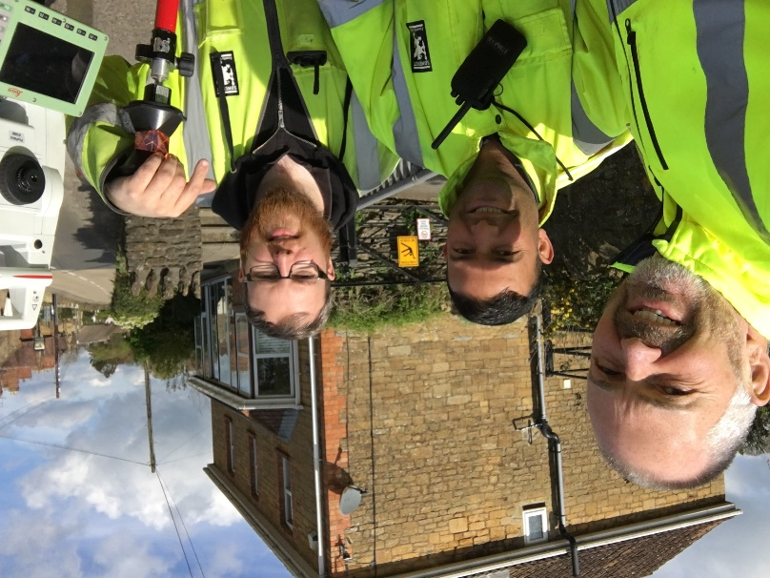
Representing you in - Barwick, Chiselborough, Closworth, East Chinnock, East Coker, Hardington Manderville, Hardington Marsh, Hardington Moor, Haselbury Plucknett, Middle Chinnock, Montacute, North Coker, North Perrott, Norton Sub Hamdon, ​Odcombe, Pendomer, Sutton Bingham, Stoford, West Chinnock, West Coker.
Useful Contacts Resources and Websites: Somerset Coronavirus Support Helpline: 0300 7906275
Cllr Mark Keating – Somerset County Council | E: MAKeating@Somerset.gov.uk | M: 07767 203968
South Somerset Area Highways Office | E: countyroads-southsom@somerset.gov.uk | T: 0300 123 2224
Report Pothole/Road Defect | E: roadsandtransportSD@somerset.gov.uk | T: 0300 123 2224
Report Dead Animal/Mud on Road | E: roadsandtransportSD@somerset.gov.uk | T: 0300 123 2224
Neil McWilliams – Highways Service Manager | E: countyroads-southsom@somerset.gov.uk | T: 0300 123 2224
Lee Norman/Derek Davies – Assist Highways Service Manager | E: countyroads-southsom@somerset.gov.uk | T: 0300 123 2224
Garry Warren/Rebecca Vaughan – Traffic Engineer. Traffic & Transport Development | E: countyroads-southsom@somerset.gov.uk | T: 0300 123 2224
Gully Emptying / Road Sweeper | E: chris.holley@southsomerset.gov.uk | T: 01935 462462
Nick Allen – SSDC Ranger Scheme | E: nick.allen@southsomerset.gov.uk | T: 01935 462462
Road Records & Highway Licensing | E: Roadrecords@Somerset.gov.uk | T: 0300 123 2224

Report Adult at Risk | adults@somerset.gov.uk |  |  | T: 0300 123 2224  T: Emergency: 999
Report Child at Risk | childrens@somerset.gov.uk |  |  | T: 0300 123 2224  T: Emergency: 999
Children’s Social Care Worker out of hours Emergency Duty Team |  |  |  | T: 0300 123 2327
Fostering and Adoption www.fosteradoptsomerset.org.uk | AandFRecruitmentEnquiryLine@somerset.gov.uk |  |  | T: 0800 587 9900
www.somersetwaste.gov.uk |  | ssdc@southsomerset.gov.uk | T: 01935 462462
https://www.travelsomerset.co.uk/ |  | Travel - Drive Bus Train Walk Cycle Weather
www.somerset.gov.uk |  | generalenquiries@somerset.gov.uk | T: 0300 123 2224
http://roadworks.org/ |  | Useful website for road works info
www.facebook.com/somersetcountycouncil |  | Somerset County Council Facebook page
https://roam.somerset.gov.uk/roam/map |  | Interactive Rights of Way Map / maintenance reporting
Future Parish, Town and City Council meetings: The government announced on the 25th March that the Coronavirus regulations allowing for remote Parish, Town and City Council meetings would not be extended beyond 6th May 2021. A subsequent legal challenge launched by Hertfordshire County Council has failed in the High Court and effectively means that all Council meetings scheduled for the 7th May or later will now have to be held in public, face-to-face.
The Government have however launched a consultation on allowing remote or hybrid meetings on a permanent basis via their website:
https://www.gov.uk/government/consultations/local-authority-remote-meetings-call-for-evidence/local-authority-remote-meetings-call-for-evidence
Road map out of lockdown: From 17th May most legal restrictions on meeting others outdoors will be lifted - although gatherings of over 30 people will remain illegal. Indoors, the Rule of 6 or 2 households will apply. Most businesses but those in the highest risk sectors will be able to reopen including indoor hospitality. Venues will not have to serve a substantial meal with alcoholic drinks; nor will there be a curfew. Customers will, however, have to order, eat and drink while seated. Other locations to open include indoor entertainment such as cinemas and children’s play areas; hotels, hostels and B&Bs; and indoor adult group sports and exercise classes. Up to 30 people will be able to attend weddings, receptions and wakes, as well as funerals (awaiting confirmation on number of mourners attending funerals to be confirmed in coming days). The final step of the road map is scheduled for June 21st
Coronavirus infection rates: As at 30th April the number of confirmed Covid cases in Somerset was 20,272 (up from 19,982 on 1st April) and the number of Covid-attributed deaths 796 (787). The rate per 100,000 stands at 13.7 for Somerset with Mendip at 17.3, Sedgemoor at 17.0, South Somerset 10.7 and SW&T at 11.6. The number of total deaths across the County is currently 20% below the 5-year average and the latest R-value for Somerset is between 0.7 and 1.1.

It is vitally important to remember, even those who have had a jab, to observe Hands-Face-Space and to Ventilate indoor areas at all times.

Somerset Coronavirus Support Helpline: A single phone number continues to be available for anyone in Somerset who needs Coronavirus-related support. 0300 790 6275, is open seven days a week from 8am to 6pm.
Vaccination programme roll-out: Somerset has one of the highest vaccination rates in the country with the latest figures showing 324,147 having received at least their first vaccination or 70% of the 16+ population. In addition 151,528 have received their second dose. Take up rates across the County of the first dose remains very high: 80+ (98.7%), 75-79 (100%), 70-74 (99.7%), 65-69 (92.0%), 60-64 (97.4%), 55-59 (96.3%), 50-54 (90.8%) and 45-49 (61.2%).
One Somerset: The government’s public consultation (the only guaranteed way for the public to have a say) into changing the way local councils work in Somerset ended on the 19th April. For more information visit: www.onesomerset.org.uk

Motorcycle Road Safety: Somerset County Council’s road safety team, have launched Raise your Ride, an exciting new initiative for motorcyclists who make up only c.1-2% of traffic, but represent c.21-23% of all road casualties in the UK. The next Raise your Ride events are in Wellington on Sunday 23 May, Frome on Sunday 20 June and Yeovil on Sunday 5 September. The cost for the day is £45 per person. For more information visit www.somersetroadsafety.org/page/raise-your-ride/124/
Primary School places: This year more than 98 per cent of Somerset children were offered a primary school place at one of their top three choices, the County Council’s latest school admission figures show. Of the 5,365 primary school applications received this year: 1st preference met – 94.58 per cent (5,074 applications), 2nd preference – 3.37 per cent (181 applications) and 3rd preference – 0.56 per cent (30 applications).
Care provider support: Somerset County Council have agreed an additional £8.6 million package for 2021/22 for Care providers to help them mitigate against the financial impact of the Covid-19 pandemic. The total includes a £4.5 million substantive fee increase, and a £4.1m additional one-off 3% Covid supplement paid as a lump sum at the beginning of the financial year to help providers with cash flow.
Kickstart work placements: Somerset County Council has partnered with local employers to offer 50 six-month work placements through the Kickstart Programme, and the vacancies are now live. There are a variety of placements available that could lead to permanent jobs including laboratory stewards, engineering assistants, teaching assistants, business administration roles, grounds assistants, Young People’s Champions and more. The Kickstart Programme offers young people aged 16-24 who are claiming Universal Credit the chance to land a six-month work placement, paid at national minimum wage for 25 hours per week. Details are available through the Young Persons work coach at their local job centre.
Coastal Story Walks: Somerset’s seafaring heritage and lost legends are brought to life in a new set of ‘story walks’ being launched by the County Council. Created by local poet Chris Jelley, and brought to you by the Rights of Way Team, the set of 12 Storywalks can be accessed by phone or tablet connecting walkers to the local landscape and history. The walks are between one and five km long and are set from Brean Down in the north to Minehead in the west. Simply go to the England Coast Path Story walks page https://englandcoastpath.storywalks.info/
Duke of Edinburgh Awards Scheme: Young people inspired by the recent media attention about the D of E charity are encouraged to get in touch to learn new skills, take part in physical activities and gain an award at the end. In addition those who started an award at school, college or in a group such as Guides or Scouts, but didn’t finish are also encouraged to get in touch. A Somerset Bursary Fund offers grants to enable disadvantaged young people in Somerset to complete a D of E programme. Those aged between 14-24 living in Somerset who would like to know more are encouraged to get in touch by emailing DofE@somerset.gov.uk

